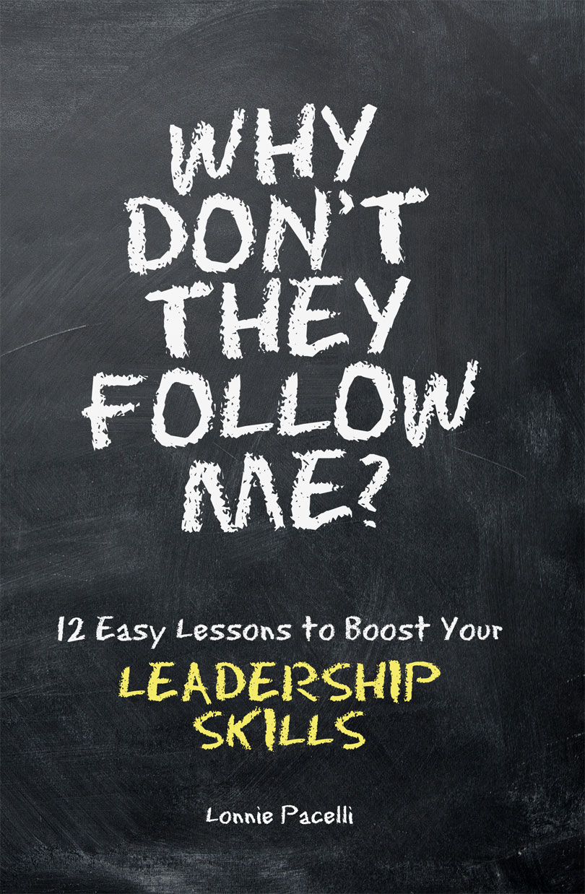  Why Don’t They Follow Me?  12 Easy Lessons to Boost Your Leadership Skills | Your Leadership Action Plan  LonniePacelli.com

Lesson | What resonated with you? | Is there anything you need to work on? | Priority (High, Medium, Low)
Humor - Credibility =
Doofus
Knowledge - Listening =
Arrogance
Action - Integrity =
Distrust
Activity - Focus =
Randomness
Wisdom - Experience = Theory
Ability - Effort =
Inaction
Leadership - Inspiration = Administration
Charisma - Conviction = Crooked Politician
Courage - Predictability =
Recklessness
Smarts - Direction = Absent-Minded Professor
Communication – Candor =
Storyteller
Decisiveness - Empathy =
Ruthlessness

Food for Thought Questions
- How long do you think it takes a leader to develop credibility with his or her team?
- Even with credible leaders, humor could get annoying. When do you think humor becomes annoying even with credible leaders?
- What in your mind is the difference between confidence and arrogance in a leader?
- Action-oriented leaders can be very effective. When do you think action-oriented leaders become ineffective?
- Is being theoretical always bad? Why or why not?
- Have you ever been frustrated by a lazy leader? How so?
- Where have you seen a leader who is administratively strong be ineffective as a leader?
- What in your mind is the difference between conviction and obstinance?
- Taking risks as a leader is important. What in your mind is the difference between a calculated risk and a foolish risk?
- Are great thought leaders (think Bill Gates or Steve Jobs) predisposed to be great people leaders? Have you seen a great thought leader crash and burn as a people leader?
- Have you ever worked with a leader who is/was a great communicator? What made him/her great?
- How would you advise a leader whose focus on the bottom-line trumps empathy?
- Have you ever worked with a leader who manages up to his/her boss better than he or she manages down to his/her organization? How did you feel about it?
- Based on bosses you've had, what would you say are positive leadership attributes?
- Based on bosses you've had, what would you say are negative leadership attributes?

